***PROJECT REPORT***

***RAJAH SERFOJI GOVERNMENT COLLEGE***

***THANJAVUR***

***DEPARTMENT OF STATISTICS***

***NAAN MUDHALVAN***

***Data analytics with tableau***

***Project name:***

***Unlocking insights into the global airtransportation network with tablau.***

***Team details:***

|  |  |  |
| --- | --- | --- |
| ***NAMES*** | ***NM ID*** | ***POSITION*** |

|  |  |  |
| --- | --- | --- |
| ***RAJA RAJAN. M*** | ***2220BA774746C32AD7E444FF7BCC594C*** | ***Team leader*** |
| ***SELVAM. C*** | ***1C0071939757C769BA8413475AA63FA2*** | ***Team member*** |
| ***THAYANITHIMARAN. A*** | ***7D5C84447B0378C836B46E1D79A9EEFB*** | ***Team member*** |
| ***HARIHARASUDHAN. K*** | ***E249A391F738752A9B04D3B09BF5EE23*** | ***Team member*** |

***GUIDED BY***

***DR.A.JOUSHVA JOSEPH***

Content

1 INTRODUCTION

1.1 Overview

1.2 Purpose

2 Problem Definition & Design Thinking

2.1 Empathy Map

2.2 Ideation & Brainstorming Map

3 RESULT

4 ADVANTAGES & DISADVANTAGES

5 APPLICATIONS

6 CONCLUSION

7 FUTURE SCOPE

8 APPENDIX

1. Source Code

***1 INTRODUCTION***

***Overview :***

*The project uses a comprehensive dataset that contains information on airports, airlines, and their routes. The dataset includes details such as names, cities, countries, codes (IATA and ICAO), longitudes, latitudes, altitudes of airports across the world with detailed time zone and daylight saving time data. It also covers information about airlines including their IDs, name aliases, IATA and ICAO codes, callsigns country of origin and active/inactive status. Similarly, it also covers route details such as airline sources to destination airports along with essential details like codeshare stakeholder if any stops required during this journey along with the type of aircraft being used for that particular journey .*

T*he project aims to create a dashboard and story using Tableau to analyze the Global Air Transportation Network dataset. The project is guided and provides step-by-step instructions on how to create the dashboard and story .*

***Purpose:***

*The purpose of the* ***Tableau project*** *that analyzes the* ***Global Air Transportation Network*** *is to create a dashboard and story using Tableau to analyze the Global Air Transportation Network dataset. The project aims to provide insights into the air transportation network from around the globe. The dataset used in this project is a comprehensive collection of information on airports, airlines, and their routes. It contains information such as names, cities, countries, codes (IATA and ICAO), longitudes, latitudes, altitudes of airports across the world with detailed time zone and daylight saving time data. It also covers information about airlines including their IDs, name aliases, IATA and ICAO codes, callsigns country of origin and active/inactive status. Similarly, it also covers route details such as airline sources to destination airports along with essential details like codeshare stakeholder if any stops required during this journey along with the type of aircraft being used for that particular journey.*

***2.Problem definition & Design Thinking:***

***Empathy map:***

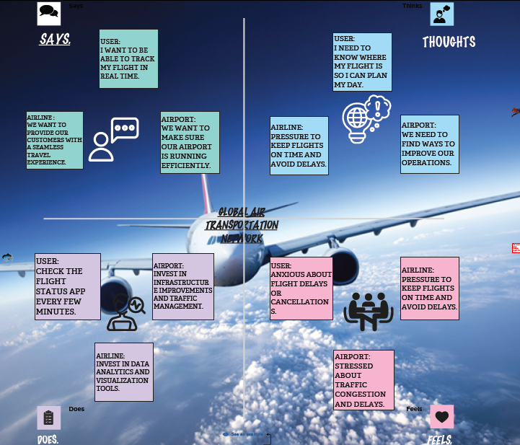

***Brainstorm idea prioritization:***

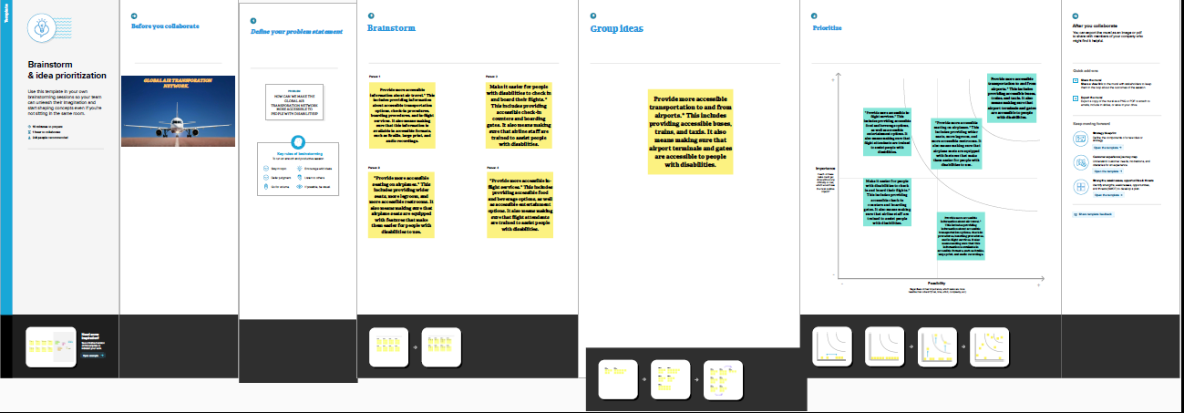

***3 .RESULT:***

***DASHBOARD1***

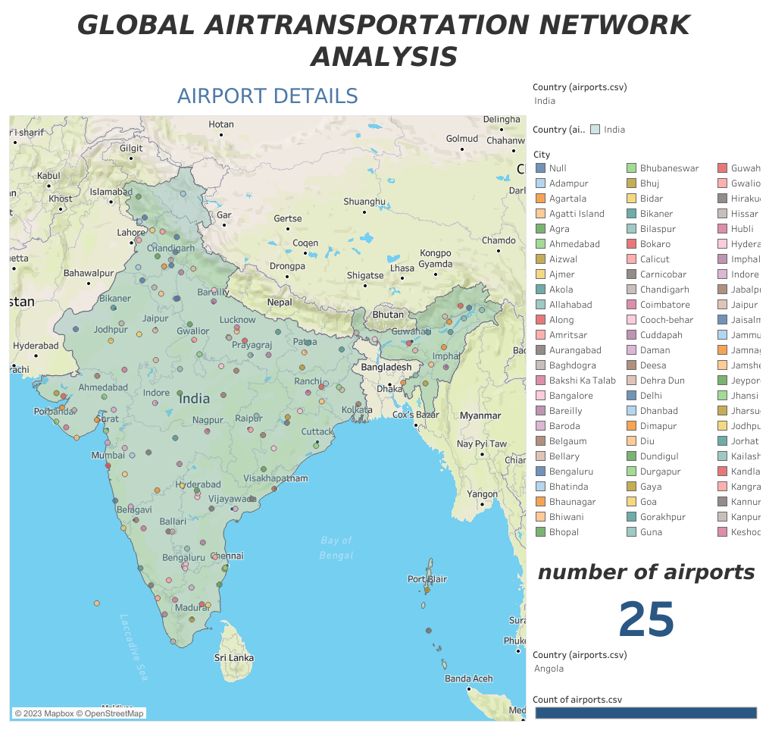

***DASHBOARD2***

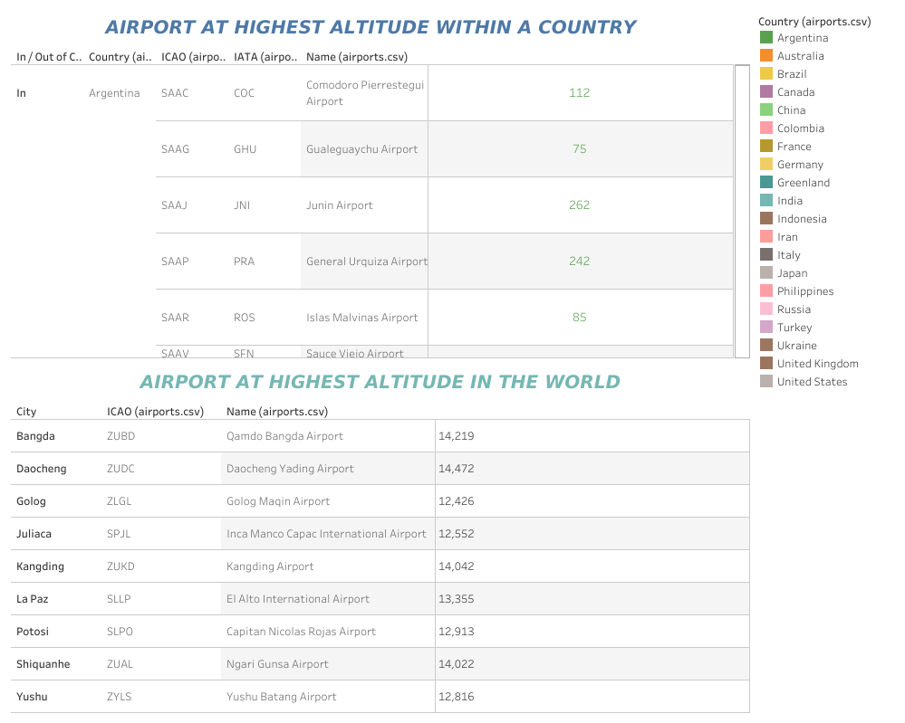

***DASHBOARD3***

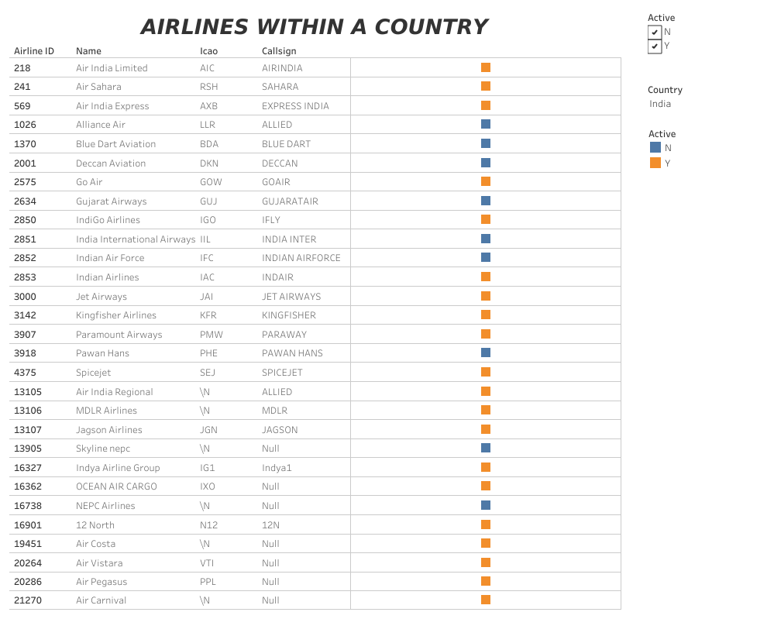

***DASHBOARD4:***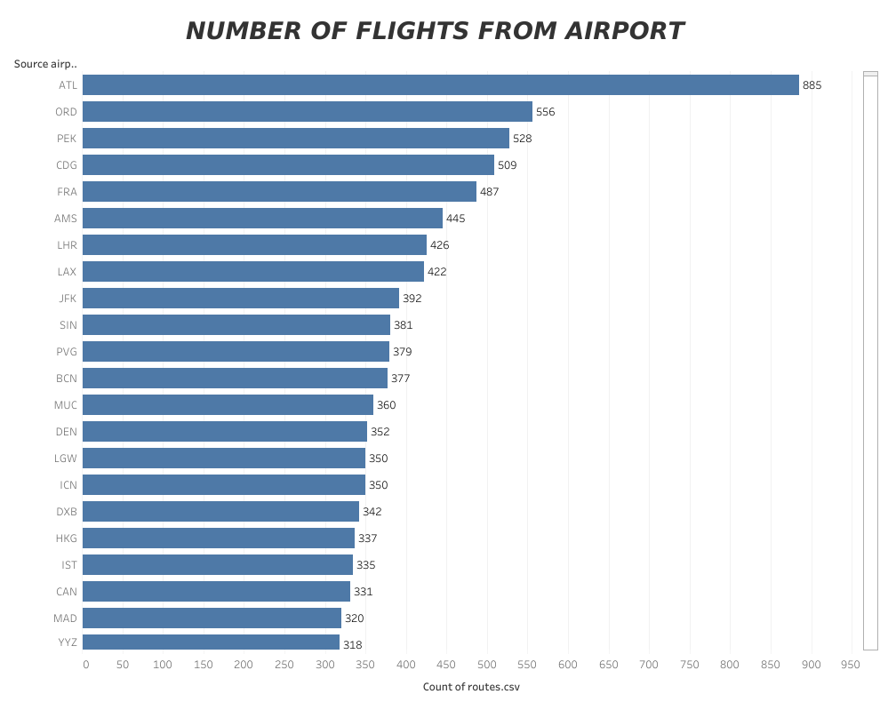

***STORY:***

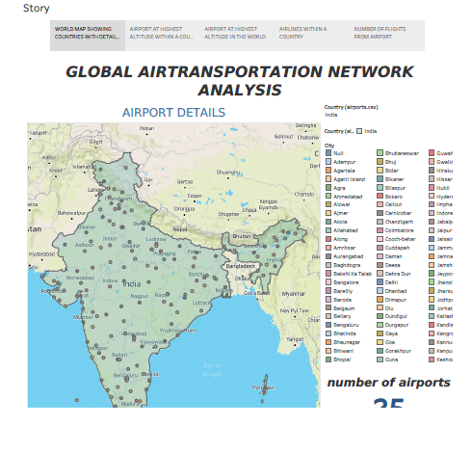

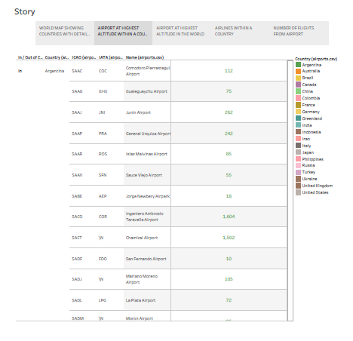

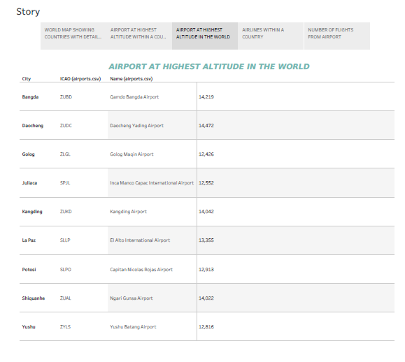

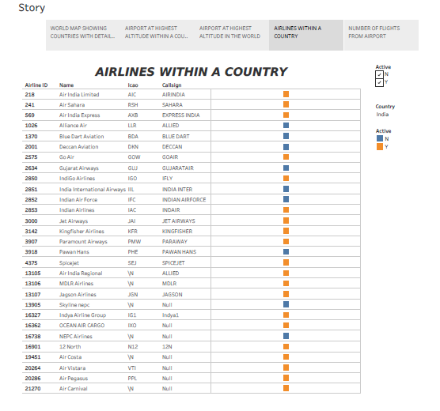

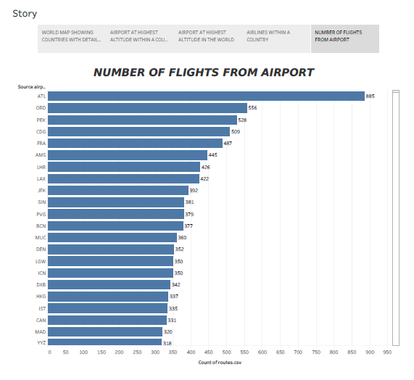

***4.ADVANTAGES AND DISADVANTAGES:***

***Advantages of using Tableau for analyzing the global air transportation network:***

***1. Data Visualization: Tableau is known for its powerful data visualization capabilities. It allows you to create interactive and visually appealing charts, maps, and graphs that can help you explore and understand complex data related to the global air transportation network. This can make it easier to identify patterns, trends, and anomalies.***

***2. Real-time Analysis: Tableau supports real-time data connections, which means you can analyze and visualize the most up-to-date information about the global air transportation network. This is particularly useful when dealing with dynamic data that changes frequently, such as flight schedules, passenger volumes, and route information.***

***3. Interactive Dashboards: Tableau allows you to create interactive dashboards that provide a comprehensive view of the global air transportation network. You can customize these dashboards to display the specific metrics and dimensions that are relevant to your analysis, and users can interact with the data by applying filters, drilling down into details, and exploring different perspectives.***

***4. Integration with Multiple Data Sources: Tableau can connect to a wide range of data sources, including databases, spreadsheets, cloud services, and web APIs. This flexibility makes it easier to gather data from various sources related to the global air transportation network and combine them into a single analysis. You can also perform data blending and join operations to enrich your analysis with additional information.***

***5. Collaboration and Sharing: Tableau provides features for collaboration and sharing, allowing you to collaborate with colleagues or stakeholders on your analysis of the global air transportation network. You can share interactive dashboards, reports, and visualizations with others, either by publishing them to Tableau Server or Tableau Public, or by exporting them to different formats such as PDF or image files.***

***Disadvantages of using Tableau for analyzing the global air transportation network:***

***1. Steep Learning Curve: Tableau can be complex for beginners, especially if you're not familiar with data visualization concepts or the Tableau interface. Building advanced visualizations and utilizing more advanced features may require a significant learning curve and investment of time.***

***2. Cost: Tableau is a commercial software, and depending on the version and licensing model you choose, it can be relatively expensive. This may be a disadvantage for individuals or small organizations with limited budgets.***

***3. Performance Limitations: When dealing with large and complex datasets, Tableau's performance may be impacted. Resource-intensive operations such as data blending, calculations, and rendering may slow down the analysis, especially if the hardware infrastructure is not optimized.***

***4. Limited Statistical Analysis Capabilities: While Tableau offers basic statistical functions and calculations, it is not as robust as dedicated statistical analysis tools. If your analysis of the global air transportation network requires advanced statistical modeling or hypothesis testing, you may need to supplement Tableau with additional statistical software.***

***5. Dependency on Data Structure: Tableau relies on well-structured and properly formatted data for optimal analysis and visualization. If the data related to the global air transportation network is messy or inconsistent, you may need to invest additional effort in data preparation and cleaning before it can be effectively used in Tableau.***

***It's worth noting that the advantages and disadvantages listed above are specific to using Tableau for analyzing the global air transportation network, and may not apply universally to all analysis scenarios. Additionally, advancements in Tableau and changes in the software landscape may have occurred after my knowledge cutoff in September 2021, so it's always a good idea to consult the latest information and user reviews when considering a specific tool for your analysis needs.***

***APPLICATION:***

***applications of Tableau for analyzing the global air transportation network:***

***1. Network Visualization: Tableau allows you to create interactive network visualizations that depict the connections between airports, airlines, and routes. By visualizing the network, you can identify central hubs, major airlines, and high-traffic routes. This can help you understand the overall structure of the global air transportation network and its key players.***

***2. Passenger Flow Analysis: Tableau can help you analyze passenger flow through airports and airlines. By visualizing data such as passenger volumes, origins, destinations, and connecting routes, you can gain insights into travel patterns and passenger preferences. This information can be used to optimize operations, improve customer experience, and identify potential market opportunities.***

***3. Flight Performance Metrics: Tableau enables you to analyze flight performance metrics, such as on-time performance, flight delays, and cancellations. By visualizing these metrics over time, you can identify trends, patterns, and potential causes of disruptions. This analysis can assist airlines and airports in improving operational efficiency, reducing delays, and enhancing the overall travel experience.***

***4. Revenue Analysis: Tableau can be utilized to analyze revenue data in the air transportation industry. By integrating data on ticket sales, ancillary services, and pricing, you can create visualizations that provide insights into revenue streams, market segments, and pricing strategies. This analysis can help optimize revenue management, identify revenue growth opportunities, and support strategic decision-making.***

***5. Market Analysis: Tableau can assist in conducting market analysis for airlines and airports. By combining data on passenger demographics, market demand, and competition, you can create visualizations that identify market trends, customer preferences, and potential market gaps. This analysis can inform route planning, marketing campaigns, and customer targeting strategies.***

***6. Operational Efficiency: Tableau can help identify opportunities for operational efficiency improvements in the air transportation network. By visualizing data related to aircraft utilization, fuel consumption, maintenance schedules, and crew performance, you can identify areas for optimization and cost reduction. This analysis can lead to better resource allocation, improved scheduling, and enhanced operational performance.***

***7. Risk Analysis: Tableau can assist in analyzing and visualizing data related to safety and security in the air transportation network. By integrating data on incidents, accidents, and security breaches, you can identify patterns, hotspots, and potential risk factors. This analysis can support risk mitigation strategies, safety protocols, and regulatory compliance.***

***These are just a few examples of how Tableau can be applied to analyze the global air transportation network. The flexibility and visualization capabilities of Tableau allow for in-depth exploration and insights into various aspects of the industry, supporting data-driven decision-making and strategic planning.***

***CONCLUSION:***

***In conclusion, here's a summary of the key points regarding the use of Tableau for analyzing the global air transportation network:***

***- Tableau's data visualization capabilities enable the creation of interactive and visually appealing charts, maps, and graphs to explore and understand complex data related to the global air transportation network.***

***- Real-time analysis is supported, allowing for the examination of up-to-date information on flight schedules, passenger volumes, and route data.***

***- Interactive dashboards can be customized to display relevant metrics and dimensions, enabling users to apply filters, drill down into details, and explore different perspectives.***

***- Tableau's integration with multiple data sources facilitates gathering and combining data from various sources related to the global air transportation network.***

***- Collaboration and sharing features enable the sharing of interactive dashboards, reports, and visualizations with colleagues and stakeholders.***

***- Challenges with Tableau include a steep learning curve, potential cost considerations, performance limitations with large datasets, and limited statistical analysis capabilities.***

***- Tableau's applications for analyzing the global air transportation network include route analysis, passenger analysis, flight performance monitoring, revenue analysis, network optimization, fuel efficiency analysis, and safety and security analysis.***

***Overall, Tableau provides a powerful platform for analyzing and visualizing data related to the global air transportation network, offering insights that can inform decision-making, improve operational efficiency, and enhance the travel experience.***

***7.FUTURE SCOPE:***

***In conclusion, here's a summary of the key points regarding the use of Tableau for analyzing the global air transportation network:***

***- Tableau's data visualization capabilities enable the creation of interactive and visually appealing charts, maps, and graphs to explore and understand complex data related to the global air transportation network.***

***- Real-time analysis is supported, allowing for the examination of up-to-date information on flight schedules, passenger volumes, and route data.***

***- Interactive dashboards can be customized to display relevant metrics and dimensions, enabling users to apply filters, drill down into details, and explore different perspectives.***

***- Tableau's integration with multiple data sources facilitates gathering and combining data from various sources related to the global air transportation network.***

***- Collaboration and sharing features enable the sharing of interactive dashboards, reports, and visualizations with colleagues and stakeholders.***

***- Challenges with Tableau include a steep learning curve, potential cost considerations, performance limitations with large datasets, and limited statistical analysis capabilities.***

***- Tableau's applications for analyzing the global air transportation network include route analysis, passenger analysis, flight performance monitoring, revenue analysis, network optimization, fuel efficiency analysis, and safety and security analysis.***

***Overall, Tableau provides a powerful platform for analyzing and visualizing data related to the global air transportation network, offering insights that can inform decision-making, improve operational efficiency, and enhance the travel experience.***

***8.APPENDIX:***

***Source code:***

***Data Set Link 👇***

[***https://drive.google.com/drive/folders/1RJnbcGxvIVulM3fkZH1Wz3_IbLDP2RjY?usp=share_link***](https://drive.google.com/drive/folders/1RJnbcGxvIVulM3fkZH1Wz3_IbLDP2RjY?usp=share_link)

[***unlocking insights into global air transportation network analysis with tableau(RSGC)***](https://youtu.be/LpSWUYU_gE4?si=SM1MpBzIpl2rxvWq)

[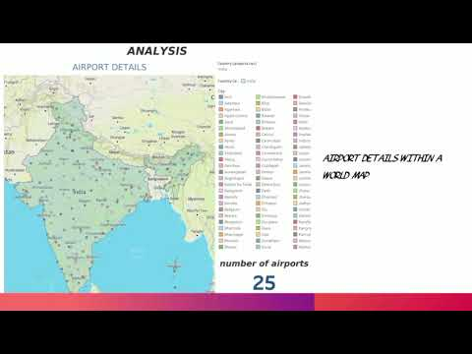](https://youtu.be/LpSWUYU_gE4?si=SM1MpBzIpl2rxvWq)